**Talend Data Catalog Installation Implementation**

**Talend Data Catalog 8.0**

**Installation Guide & Documentation**

**Contents**

Section 1:Introduction 2

Benefits of a Data Catalog 2

Section 2: Downloading the TDC.ZIP file 3

Section 3:Installation 5

Section 4:Configuration 10

# 

Approval

| Signatures by each signatory indicate their acceptance that this document is complete and accurate to the best of his/her knowledge per responsibilities outlined in this document and as guided by approved methodologies and established procedures. | | |
| --- | --- | --- |
| Talend Lead:  Artha Emp | **Subhransu** | **Date:** |
| Project Manager:  Artha Emp | **Pavan Valluri** | **Date:** |
| Talend Developer:  Artha Emp | **Omkar Patil** | **Date:** |

# **Section 1:Introduction**

As part of Talend Data Fabric, this automated data catalog provides a single, secure point of control, and is designed to make it easier than ever to discover, organize, and share trusted data. This means users can spend less time creating and aligning controls across different systems and point solutions — and more time using it to deliver the healthy data that is needed to meet and exceed their business objectives.

A data catalog tool is vital for metadata management, governance, and data discovery. If you need to take control of your data, build a trusted data culture the collaborative way, implement a data governance strategy to lock down workflows for privacy regulations

## Benefits of a Data Catalog

* Improved data efficiency
* Improved data context
* Reduced risk of error
* Improved data analysis

Features varies of Talend Data catalog

* You can collect metadata from data stores, data models, Data Integration and Business Intelligence tools, and business applications, using Talend Data Catalog bridges.
* You can manage metadata by searching for, documenting, analysing and comparing them, tracing end-to-end data lineage and performing impact analysis
* You can use the glossary model to collaboratively build and manage the organization's business concepts and terminology.
* You can document any existing data stores by using data models.

**Installation Environment**

DEV Environment

# **Section 2: Downloading the TDC.ZIP file**

#click on this link

https://www.opensourceetl.net/TalendDataCatalog

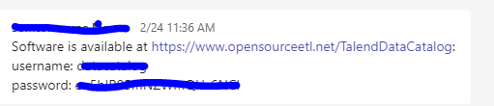

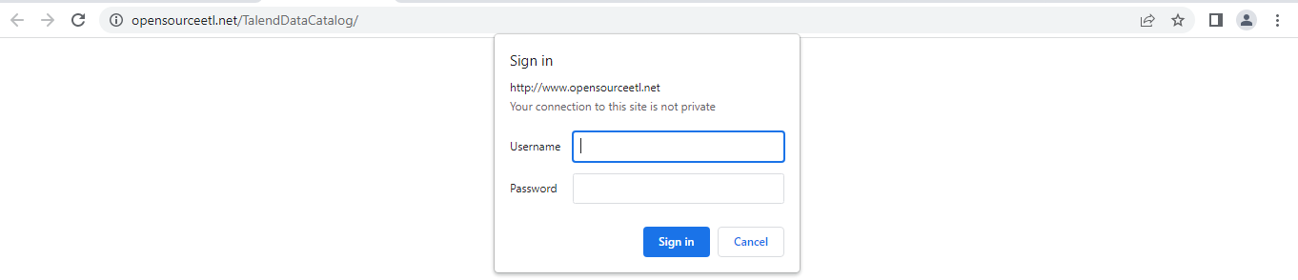

Go inside the files and download .zip file

1. 8.0
2. Software
3. Download TDC-8-20230302.zip file

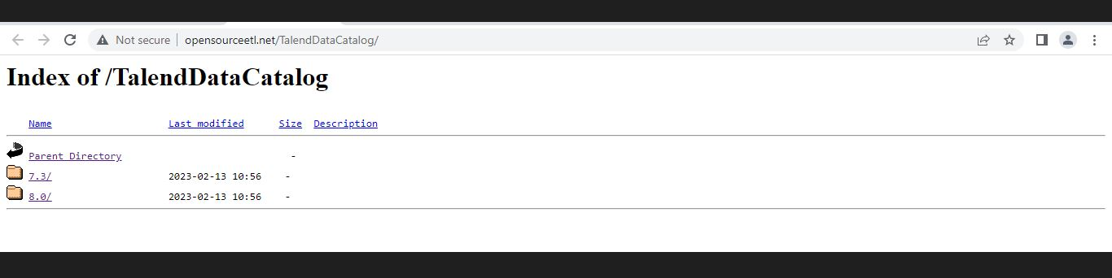

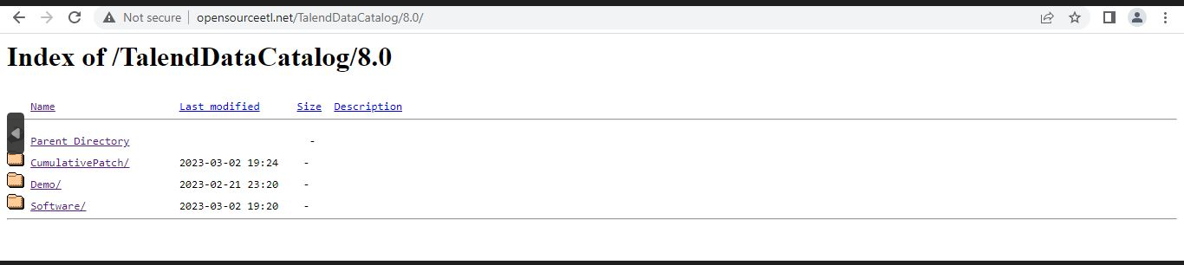

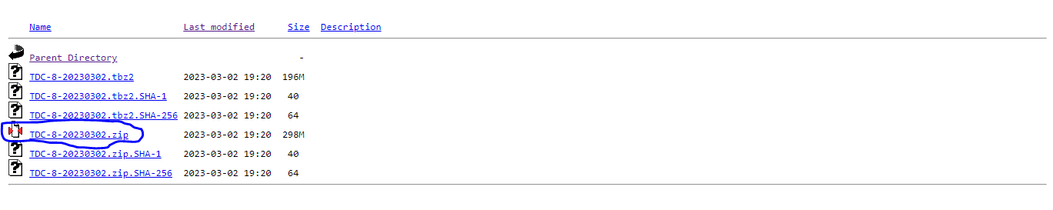

Go to the Downloaded Directory or file

1. Right click on TDC-8-20230302.zip file
2. Extract the TDC-8-20230302.zip file

# **Section 3:Installing TDC**

Go inside the TDC-8-20230302 folder.

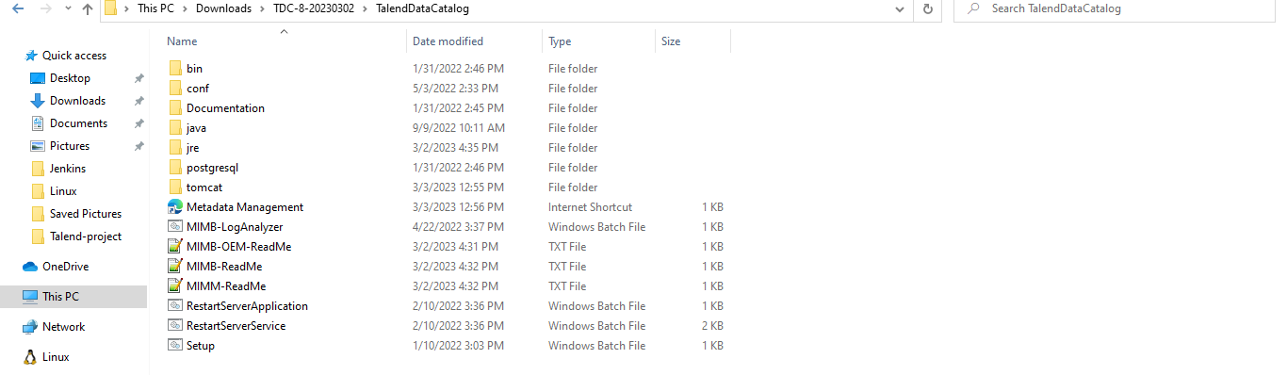

#Right click on setup.sh and run it as administrator.

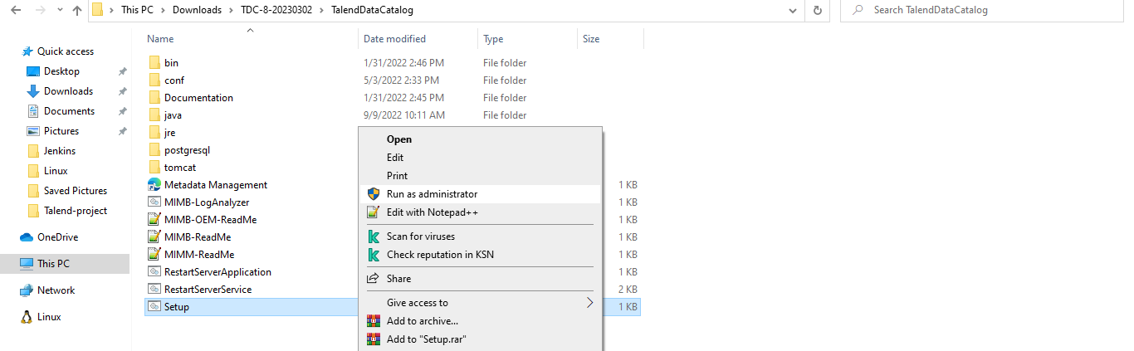

#Goto Application server

#make an installation directory in C: drive

#create new folder TDC

i) Browse the folder in data directory

#Enable windows service

#Enable rest api

#max memory 10240

#port 11480

#At last configure

Action successful

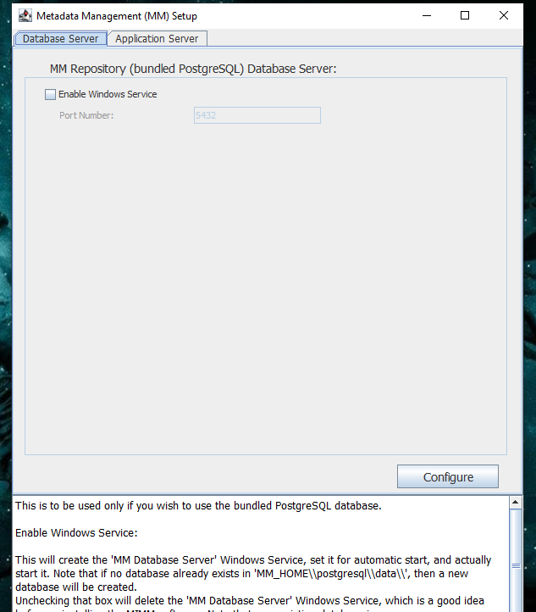

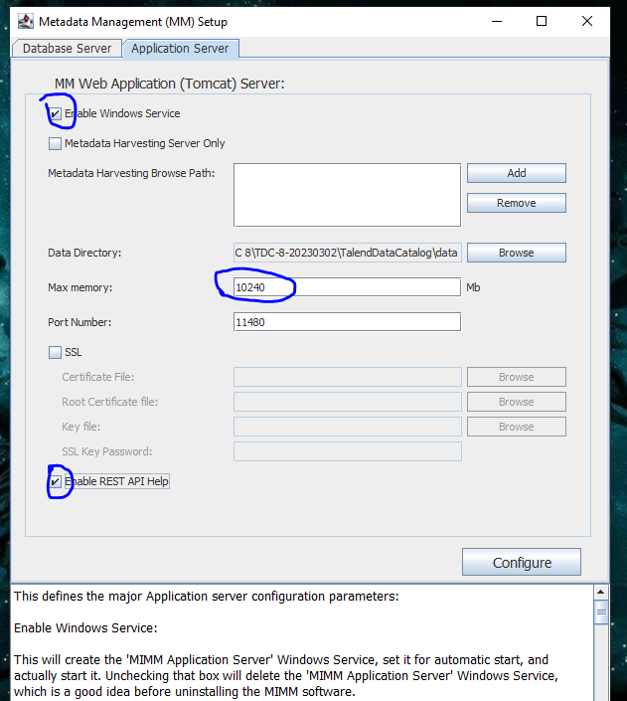

#Right click on RestartServerApplication

i)Run as administrator and restarts the application

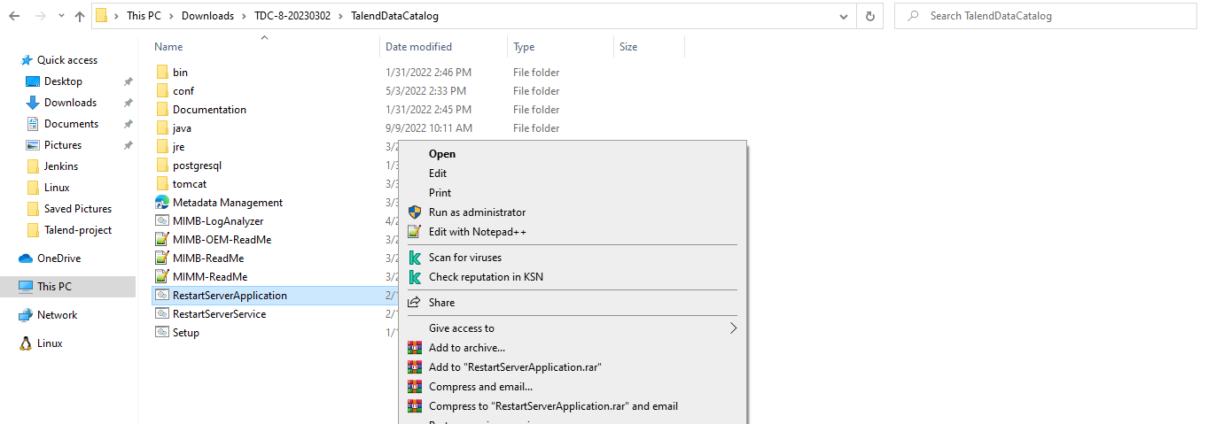

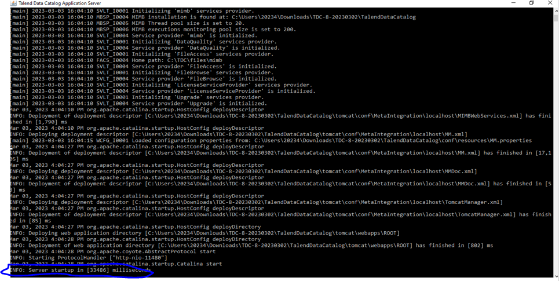#Initialize and start the TDC server in CMD

#Access the TDC from web browses

http:// 10.62.91.214:11480/MM

(or)

#Direct click on metadata management

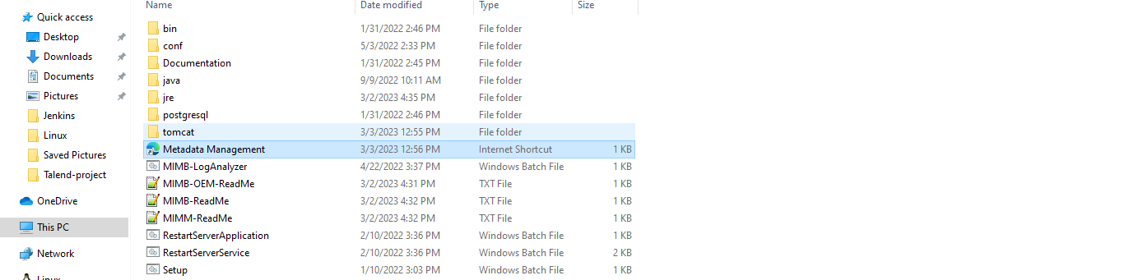

#http://10.62.91.214:11480/MM

User:- Administrator

Password:- Administrator

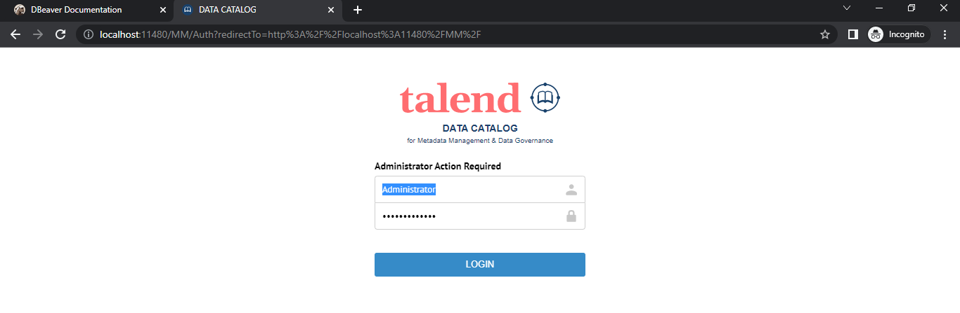

# **Section 4: Configuration**

#sign in into the TDC

#configure the database setting

#Check the database type

#Check the connection and save it.

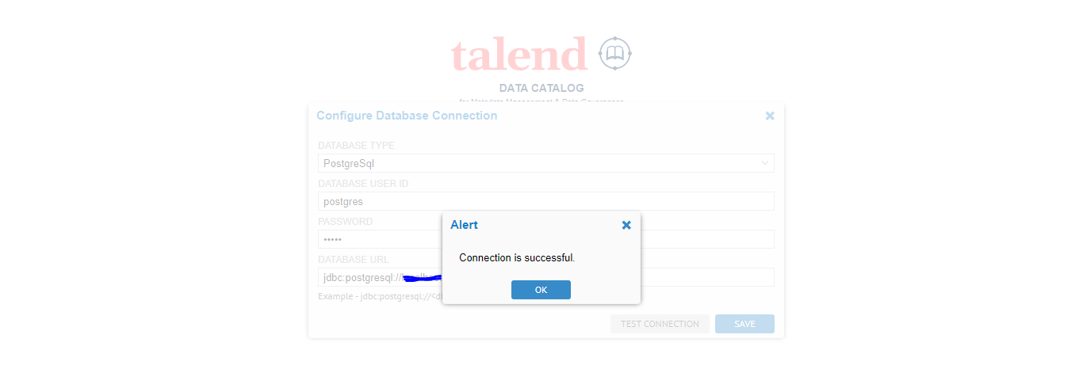

#Reload or again open the page

#Download the host.xml file

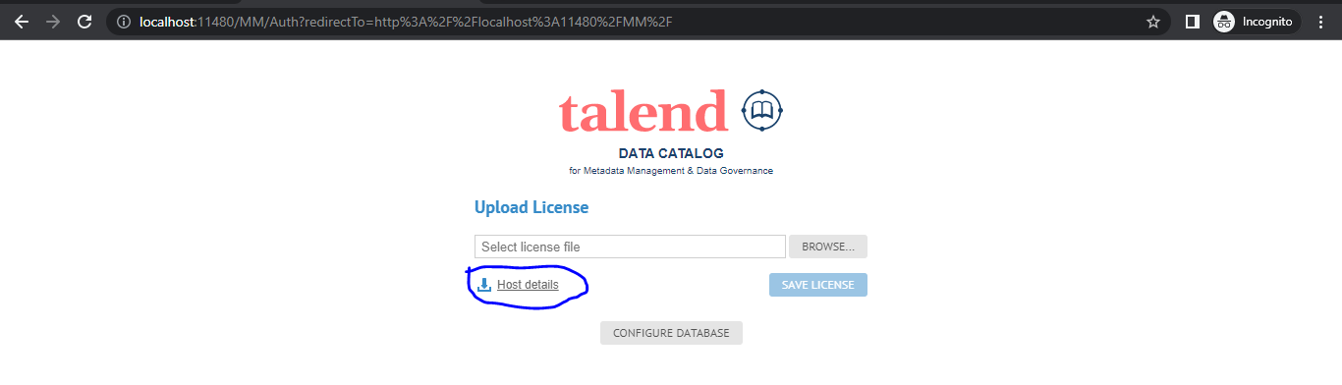

#click on the talendforge.org access token link provided by talend vendor

#Upload the Host.xml file

#license file will be sent to the email of Sales vendor

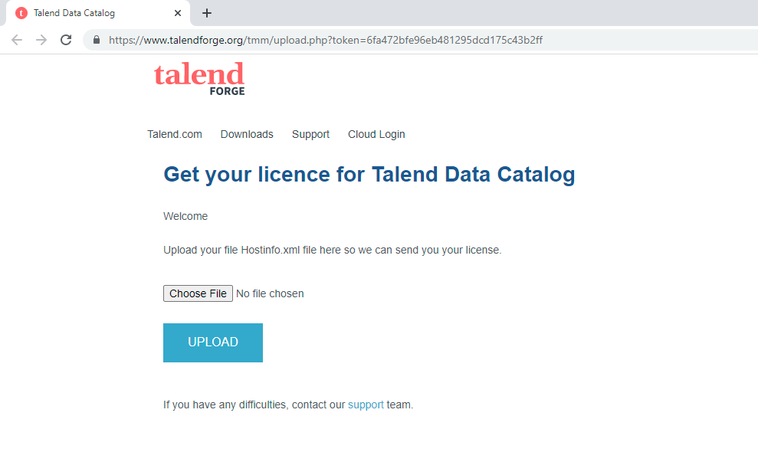

#Reload or again open the page

#give same username and password

